THE CENTRAL CONSERVATORY OF MUSIC
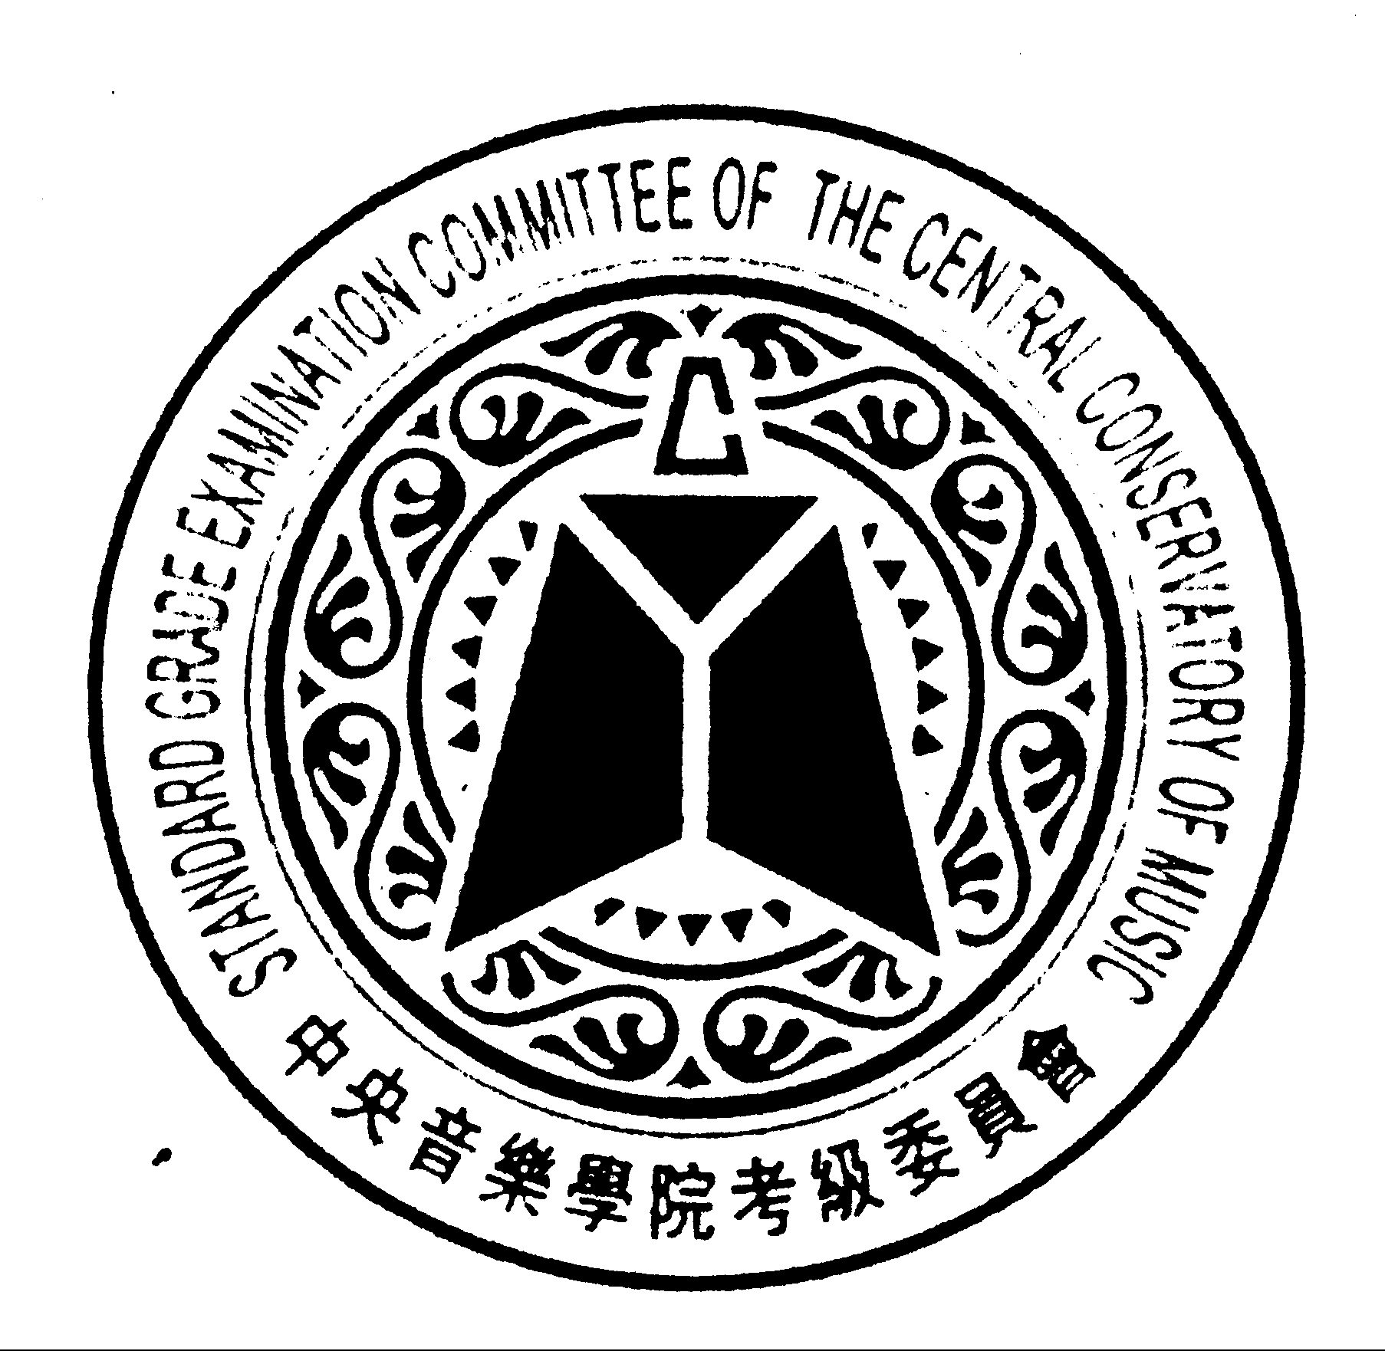

STANDARD GRADE EXAMINATION
中 國 中 央 音 樂 學 院
中樂《技術考級》

ENTRY FORM 報 名 表

CLOSING DATE FOR ENTRIES JULY 15, 2016
( Entries must be postmarked on or before the above date )

• PLEASE TYPE OR PRINT ALL INFORMATON CLEARLY AND SIGN WHERE INDICATED.
• PLEASE READ THE APPROPRIATE SECTION OF THE SYLLABUS FOR INSTRUCTIONS REGARDING CLASS REQUIREMENTS BEFORE SUBMITING ENTRY FORMS.
• FULL PAYMENT BY CHEQUE OR CASH MUST ACCOMPANY THIS ENTRY FORM BY MAIL OR HAND TO THE FOLLOWING ADDRESS :
303 - 8495 ONTARIO STREET, VANCOUVER, B.C. V5X 3E8 CANADA.
• PLEASE MAKE CHEQUES PAYABLE TO : B.C. CHINESE MUSIC ASSOCIATION or B.C.C.M.A.

Participant’s Last Name Participant’s First Name 考生中文姓名
Note : the full name entered here must match with your identity and will appear on certificate which you may be eligible.

Participant’s Mailing Address
Unit No. Street

City Province Country Postal Code

Participant’s Date of Birth Participant’s Phone Number Participant’s E-mail
Year / Month / Day Area Code Number

Teacher’s Last Name Teacher’s First Name 老師中文姓名 Teacher’s Phone Number

Teacher’s E- mail |  | TRANSLATION IF NEEDED |  | CANTONESE |  | ENGLISH

CLASS |  | GRADE |  | CLASS TITLE 樂器 |  | LAST EXAMINATION TAKEN : GRADE

ENTRY FEE ENCLOSED $ |  | CASH |  | CHEQUE |  | RECEIVED BY

NAME OF SELECTION : MUSIC 樂 曲 ETUDE 練 習 曲
1.
2.

 |  | For Office Use |  |  | Date
 |  | Entry No.
Signature of Participant, or Participant’s Teacher, or Participant’s Parents or Legal Guardian |  | Admission No.
 |  | Endorsed by :
 |  | Certificate No.
Date |  | Approved by

